# How to host a flutter web app on GitHub Pages

## Create your own account on GitHub

Open <https://github.com/> and on the top-right, press on button „Sign up“:



First you must enter your e-mail address:

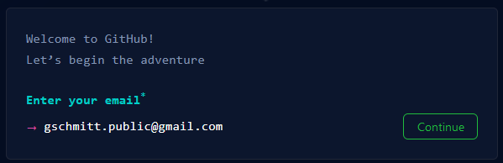

Then create a password:

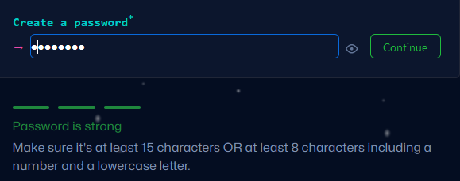

and enter a user name that is not yet used on GitHub:

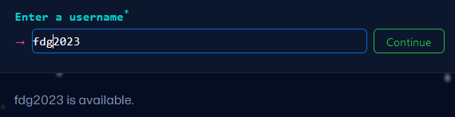

Then you can decide if you want „occasional“ emails from GitHub:

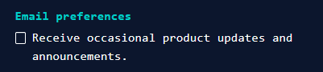

And finally you must verify that you are no Robot:

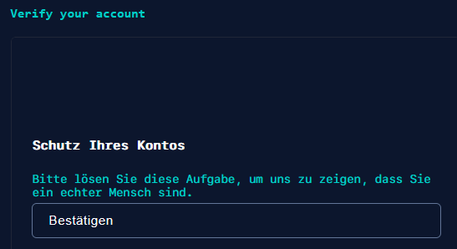

Click on „Bestätigen“ and in the next step, choose the picture on the right that has the same orientation as given on the left:

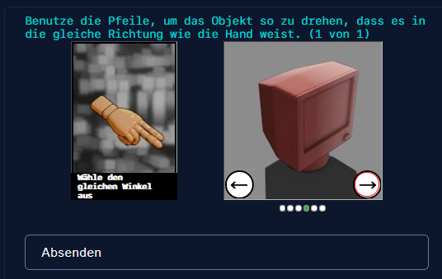

Press on „Absenden“ and finally on

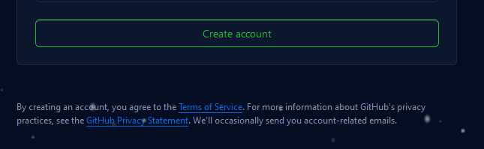

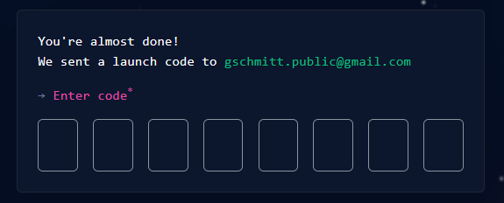

After entering this code you are asked:

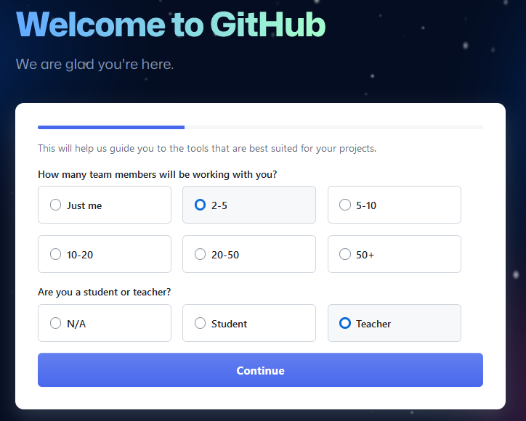

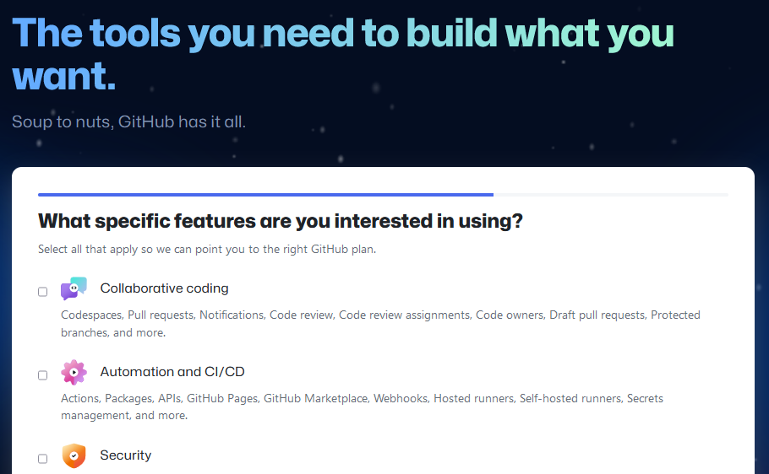

I did not check anything here …



To shorten things, I then pressed on  .

Then the dashboard is opened where you could create your first repository:

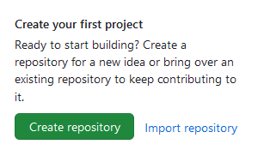

Before doing that, give a short description of yourself. To do so scroll a bit down and you will find on the right:

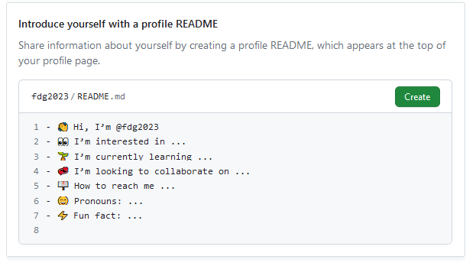

Click on Create and the following editor is opened:

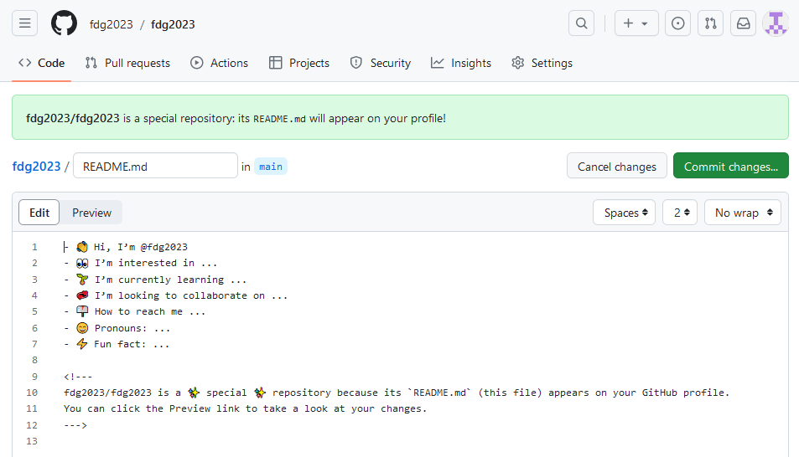

Adapt the text as you want and press on „Commit changes…“. You will be asked for a Commit Message, either take the proposed message or enter your own:

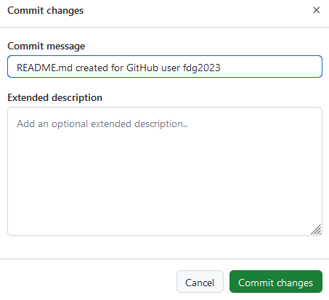

Then you are taken to the automatically created repository with the same name as your user name:

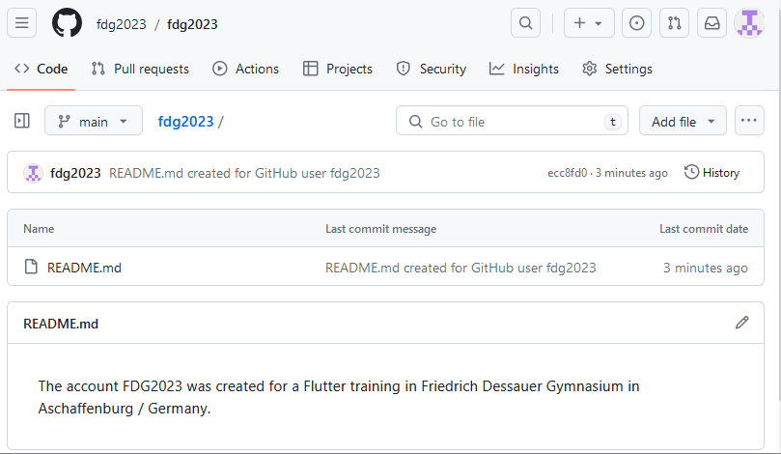

Click on the first occurance of your user name on the top to reach your GitHub home directory:

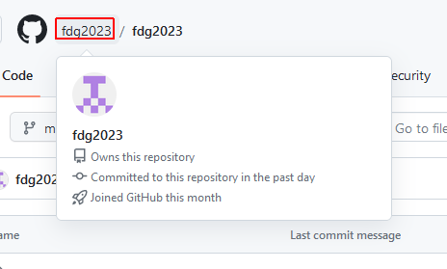

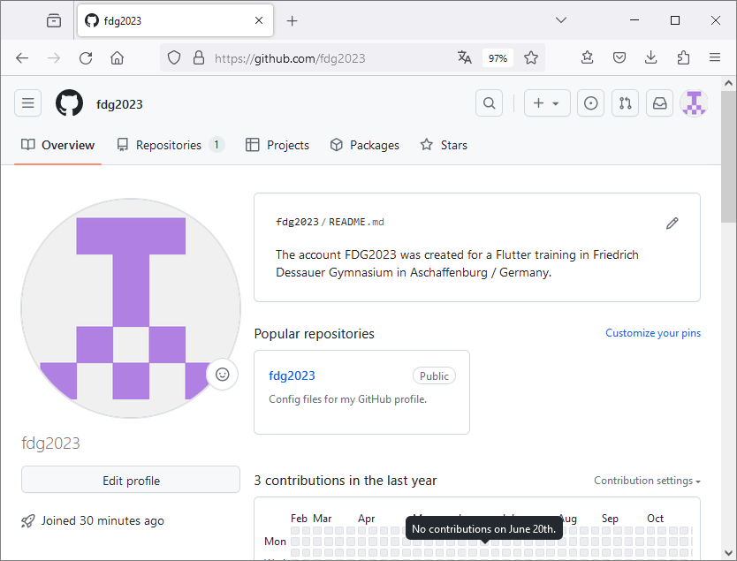

After clicking on the avatar picture on the left, you can upload whatever picture you want to replace this avatar. For our fdg2023 account I uploaded the FDG logo:

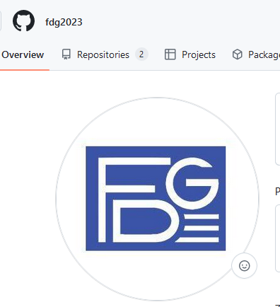

## Create a repository where your flutter web apps will be stored

When you click on the  icon top-left, you always reach your dashboard.

There you can create a new repository:

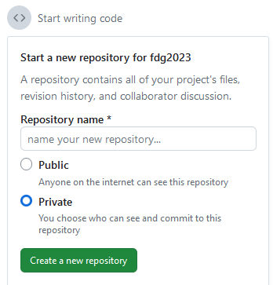

As repository name we use “web” (it’s short and fits to what we want to do) and we make it public. This is needed to make our Flutter web apps available for others.

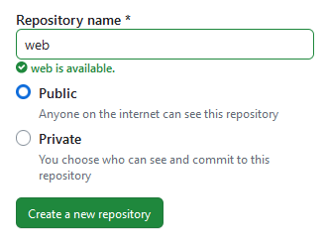

Click on the green button. Then the following page will come up:

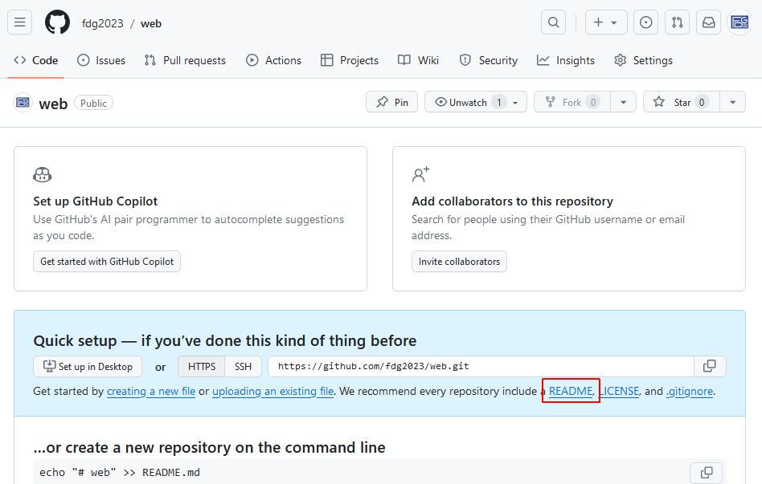

Press on the link “README” to create a short description of this new repo in the following screen:

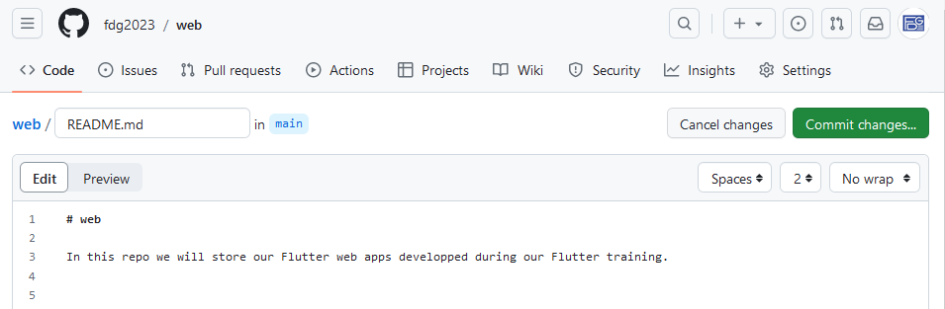

The extension “.md” stands for “MarkDown”. Markdown files allow you with a very simple syntax to create “nice looking” documents. For example lines starting with “# “ are displayed as titles. For an overview of the markdown syntax see e.g. <https://www.markdownguide.org/basic-syntax/>.

To see your formatted markdown file, switch between the tabs  on top of the editor.

When you are done, commit your changes as usual with the green button.

## Enhance your repository to host public accessible web pages

In the “menu bar” of our repository web click on “Settings” and then select “Pages” on the left:



And then select “Pages” on the right;

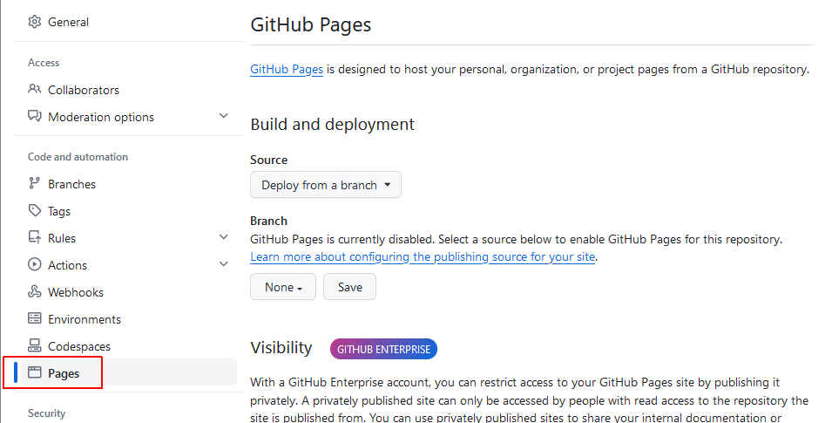

In the section “branch” under “Build and Deployment”, open the DropDown behind “None” and select “main” there:

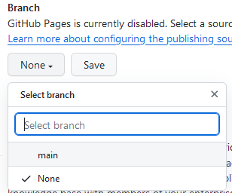 This will lead to:

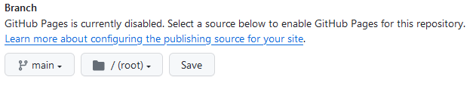

Then press on Save.

Afterwards you will see on top of the page:

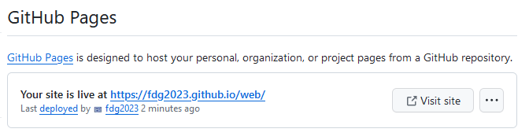

Press either on the highlighted link <https://fdg2023.github.io/web/> or on the “Visit site” button to open the base address of your repository in a web browser. It will show the README.md file of the repository:

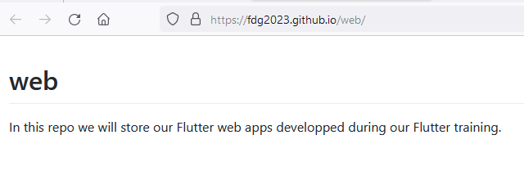

## Create a small web page in your repository (optional)

This step is not required for publishing a flutter web app. It should just show you how to create and use a simple html page in your repository.

Go to the main page of your web repository, open the DropDown “Add file” and select “Create new file”:

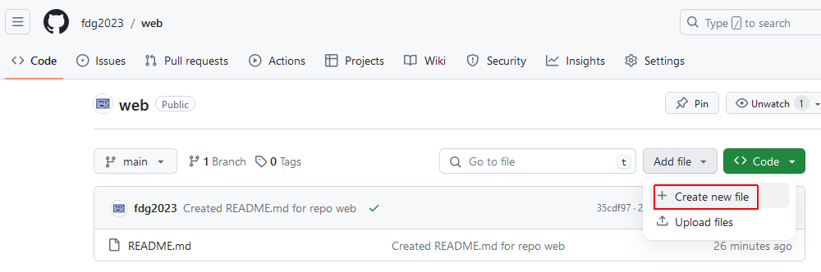

In the upcoming page, enter as name of the new file “hello.html” and copy/paste the following content:

<!DOCTYPE html>  
<html>  
<body>  
  
<h1>Greetings from Aschaffenburg !</h1>  
<p>This page is maintained by the team of a Flutter training hold in Friedrich Dessauer Gymnasium.</p>  
  
</body>  
</html>

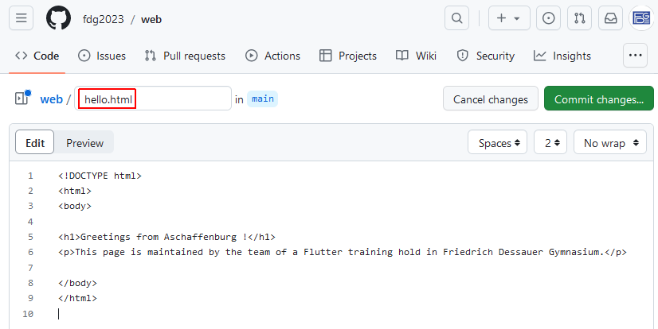

As usual commit your changes. After a short waiting time of some seconds, you should then be able to see this file in your Web Browser under the link <https://fdg2023.github.io/web/hello.html>

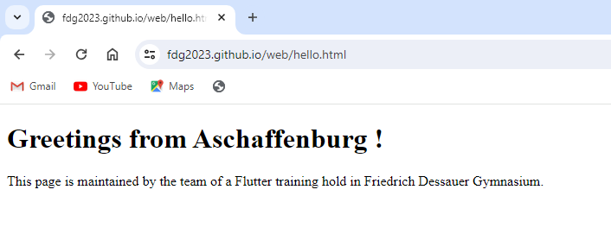

## Publish your flutter app in the web repository on GitHub

As a sample we take our flying_balls app. We want to deploy it into our repository “web” under the folder “flying_balls”, so that at the end the app can be reached via the link

<https://fdg2023.github.io/web/flying_balls>

Open your flying_balls Flutter project in Visual Studio Code, then open a new Terminal by selecting the menu

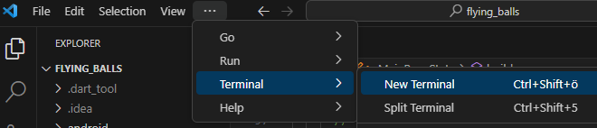

In the Terminal enter the following command:

flutter build web --base-href /web/flying_balls/

The parameter “--base-href /web/flying_balls/” tells the build process that our app will be placed under the relative path “/web/flying_balls/” below our root path <https://fdg2023.github.io>.

The build command will come up with the following output:

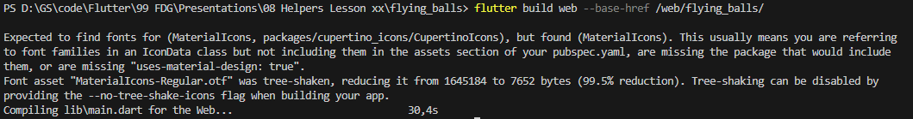

To be honest I do not understand this because in our pubspec.yaml we have the line

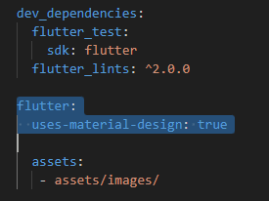

Therefore I just ignored this output. The command created a folder “web” under the build directory of your project:

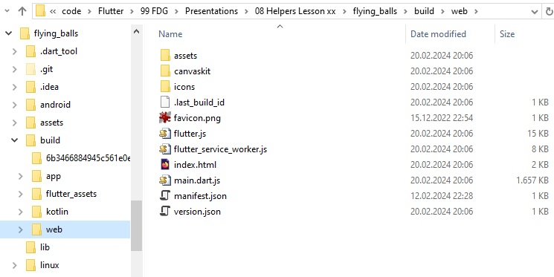

Copy this directory to some other folder on your PC and rename it to “flying_balls”:

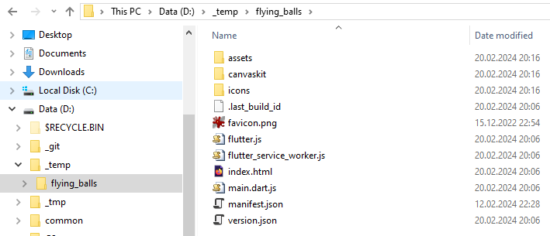

Now go to GitHub, open your repository “web” and press on

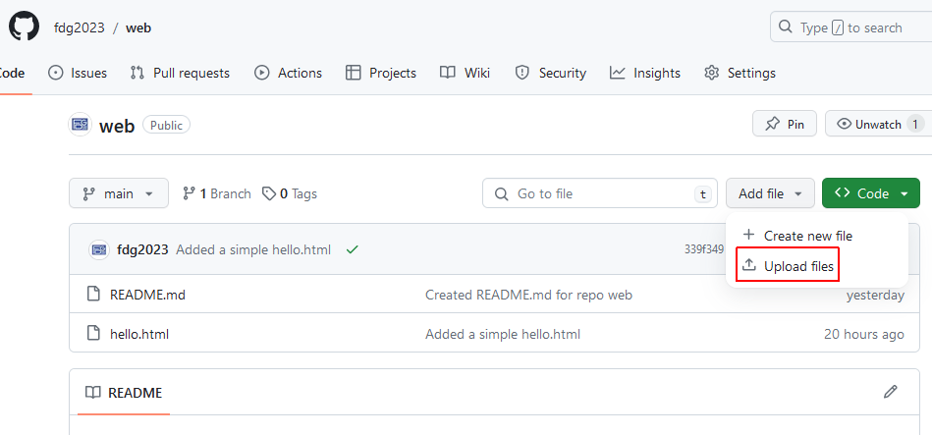

Then drag the new created folder “flying_balls” into the destination area for the files to be uploaded:

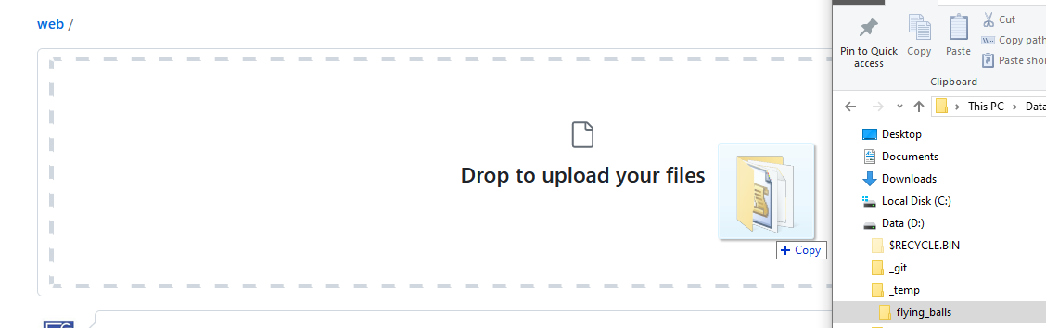

It shows the upload progress:

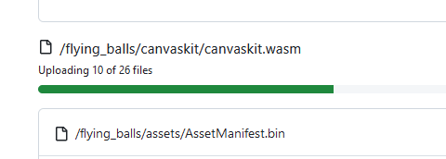

and finally you see at the bottom of the page:

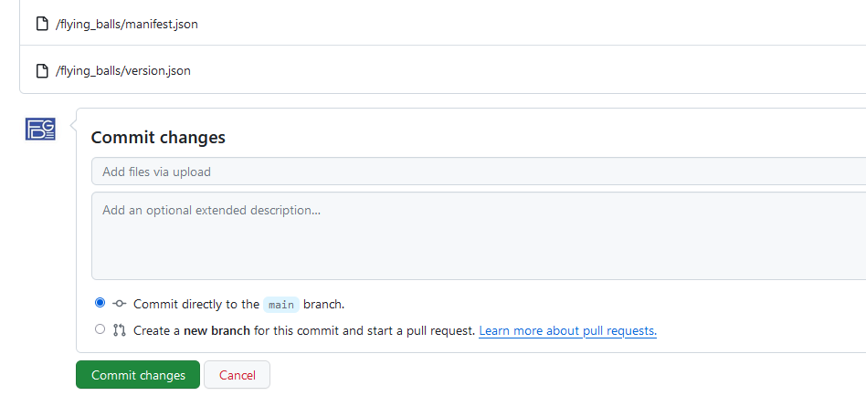

I changed the very general text “Add files via upload” to “First upload of flutter web files for flying_balls” and then pressed the green Commit button.

You will see the message

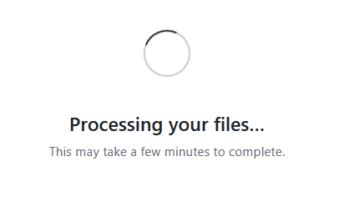

which for me ended already after a few seconds.

In our “web” repository we then see the new created folder:

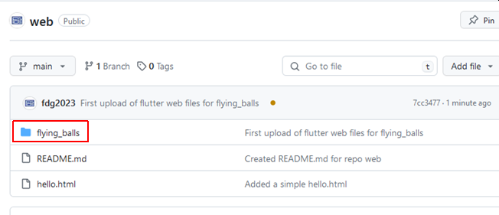

and when you now open the link <https://fdg2023.github.io/web/flying_balls> in a browser, our app should come up:

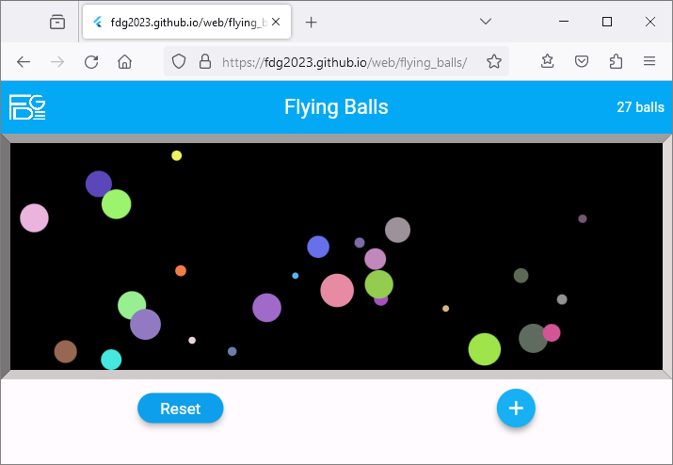

## Upload a new version of your app to GitHub

In case you have fixed some bugs or added new features to your app, what steps are needed to upload the new version to your repository ?

First build the web app as described above with the command

flutter build web --base-href /web/flying_balls/

in Visual Studio Code Terminal.

Then open your “web” repository in GitHub and click on the directory “flying_balls” there. This will open the details view of this directory:

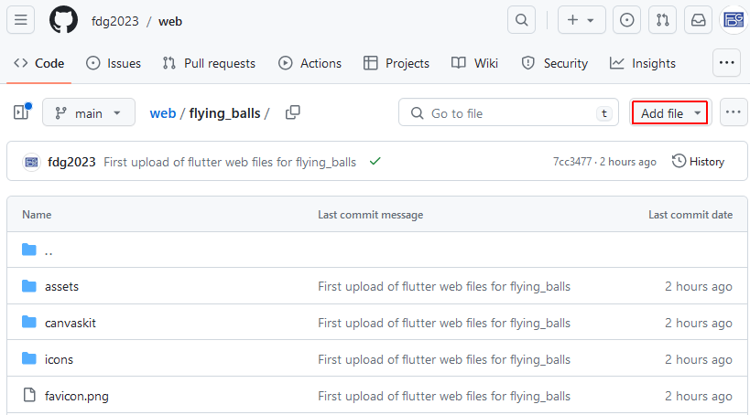

Press on “Add file / Upload files” to open the drop area.

Now open the “web” folder under the build directory of your project in Windows Explorer and press Ctrl+A to select all files there. Then drag them to the drop area in the GitHub page:

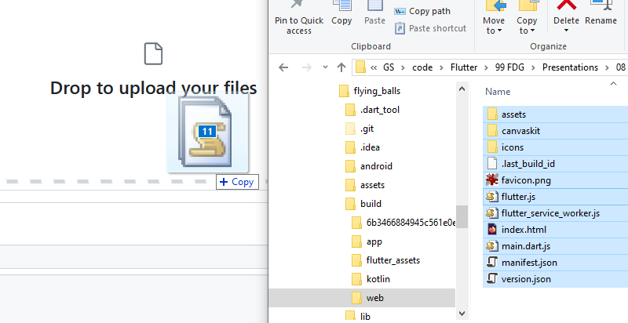

Wait until all files are uploaded and then fill the Commit Message at the bottom of the page. In my case I entered:

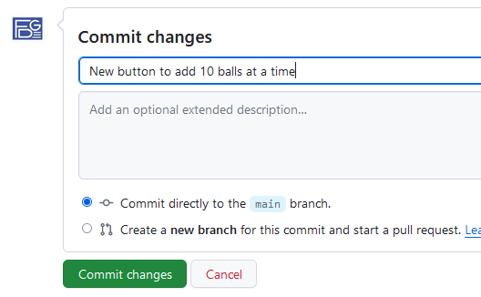

Finally open your updated app via the usual link <https://fdg2023.github.io/web/flying_balls> and test that your changes were correctly delivered.

## Install a Flutter WebApp on your phone using Chrome or Samsung Internet Browser

I saw this when testing Canasta end of April in browsers on the phone.

In Chrome after clicking on „the 3 points top right“:

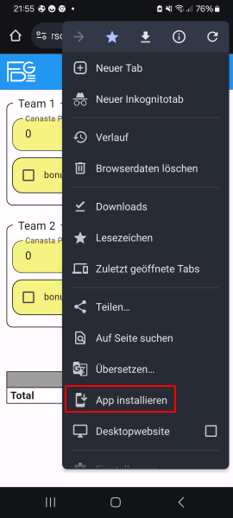

Chrome also creates a shortcut to the app in your “start screens”.

BTW: for “normal” web pages you see instead of “App installieren” the entry “zum Startbildschirm hinzufügen”.

In Samsung Browser use the Download button :

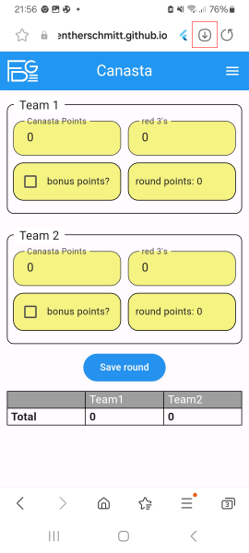 and he will ask: 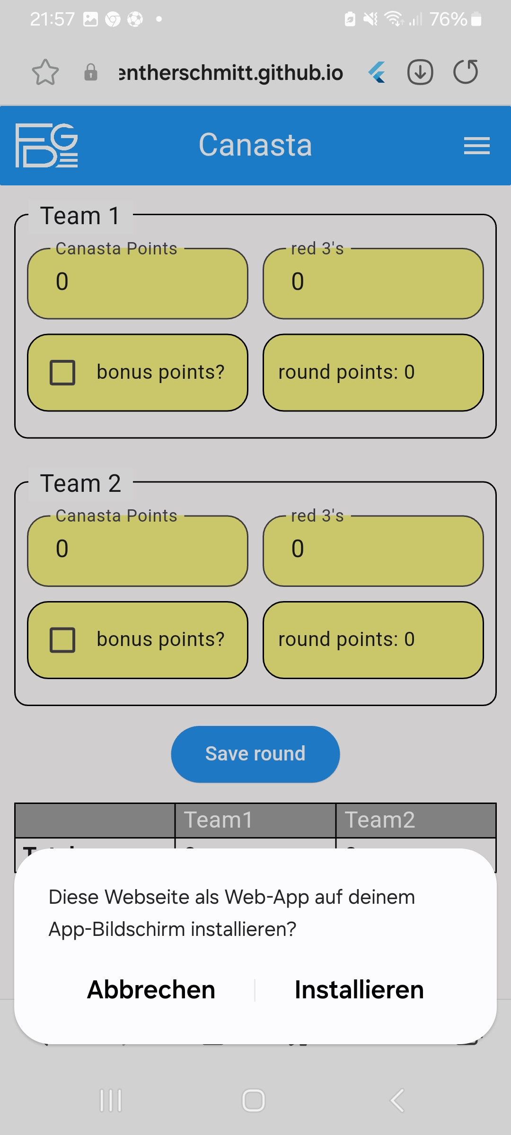

The downloaded apps work also in offline mode.

At the end you will have the app 3 times in your app screen:

Instaled during debug in VS Code, installed from Chrome and installed from Samsung Browser:

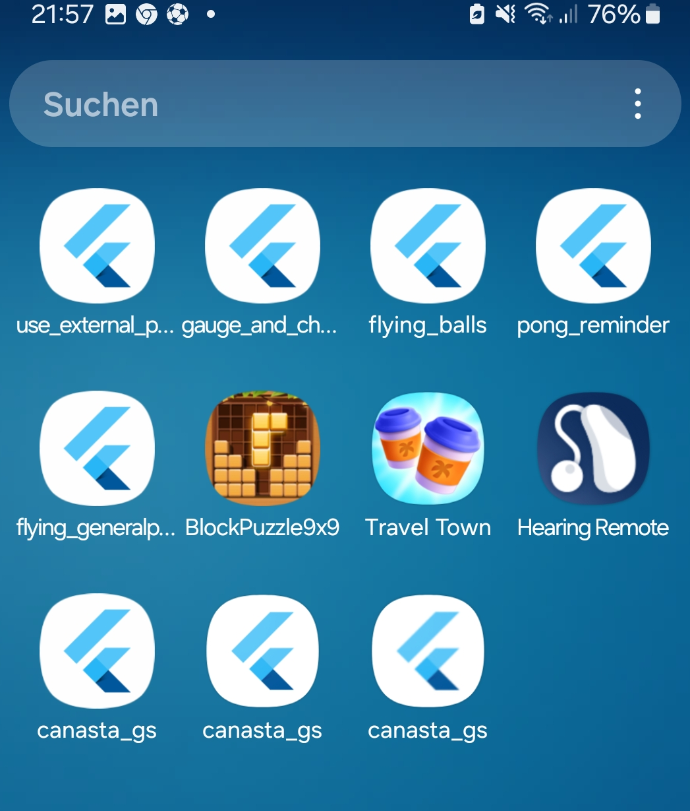

## Invite collaborators to a repository

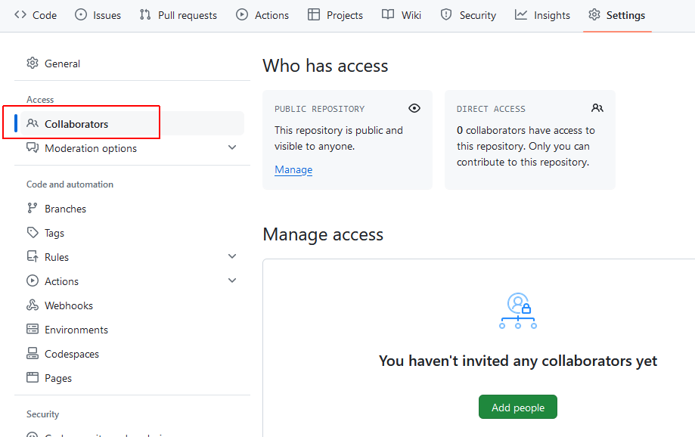

Press on “Add people”:

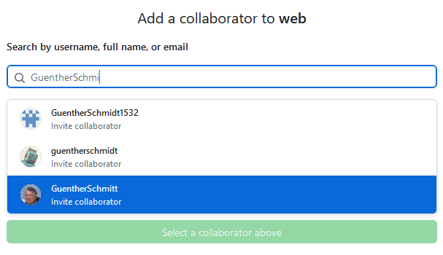

Then I saw under my GitHub account:

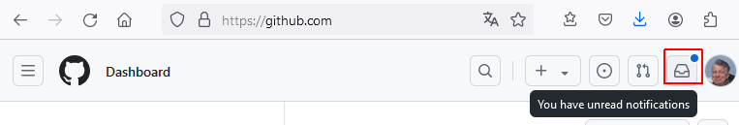

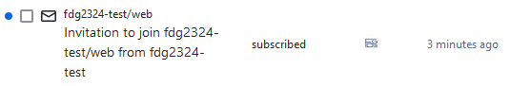

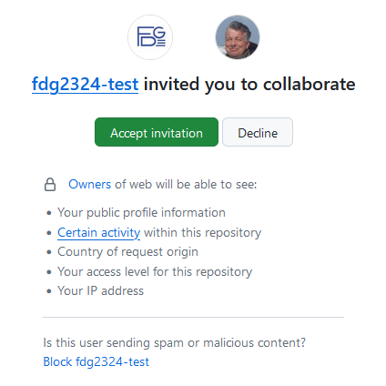



## Publish to Telekom Webspace

I use FileZilla for uploading to our telekom web side:

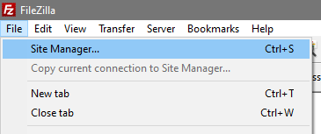

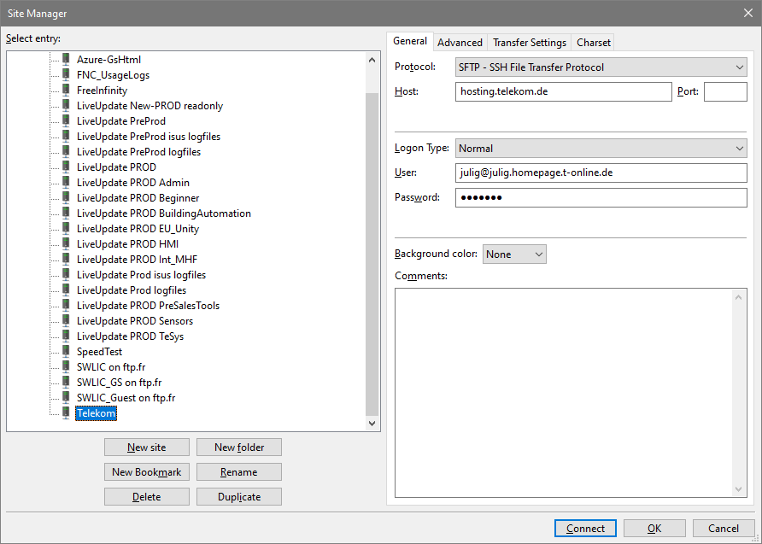

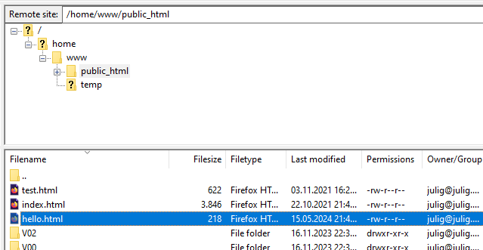

Afterwards you see via <http://www.julig.de/hello.html> :

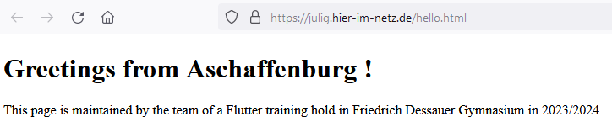

BTW: The picture carousel on julig.de was created several years ago at a time where I did not know Flutter.

Instead I used „Bootstrap“, which is a toolkit for HTML and CSS:

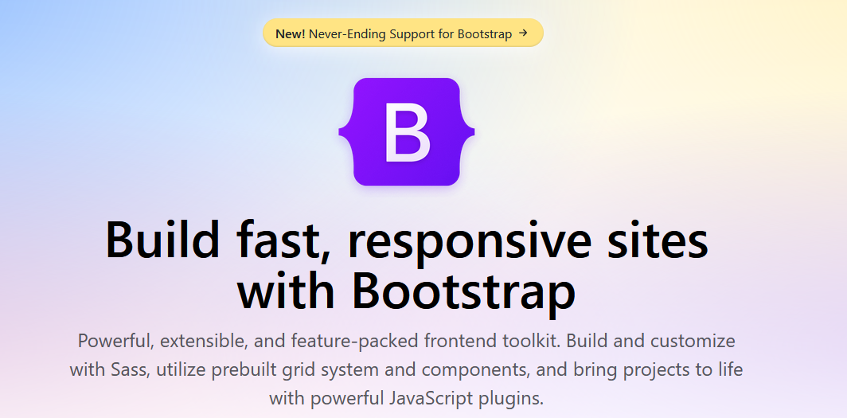

As an introduction to Bootstrap I had used several videos on Youtube, for example

<https://www.youtube.com/watch?v=D-h8L5hgW-w>

where a quite professional looking web side is created step-by-step using Bootstrap.